**Wireless Electrical Appliances Control System Using IR Communication**

**ABSTRACT:**

Controlling electrical appliances through IR remote is interesting and very useful application. This system is widely used in industries, offices, Banks, hotels, hospitals, and display boards. In this project, IR is used for controlling any appliance in an industry by controlling the loads.

IR rays are transmitted through remote and these rays are received by a receiver named TSOP 1738. Here, in this project two microcontrollers are used, one for master SECTION and other for slave section. The IR rays received by TSOP are given to the master section. from master section, IR signals are given to slave section for LED indication and are displayed on 7-segment for the respective loads. Now, from MASTER section, the loads are controlled through triac driving circuit. In the triac driving circuit, as the controller cannot provide sufficient current, MOC’S are used to drive these triacs and these triacs in turn are connected to loads. Next, in the slave section, the door opening and closing is done through a stepper motor rotating in clockwise and anticlockwise direction respectively. In this, for every respective load on activation, a message is shown on 7 segment display as load1 , load2, load3, load4, load5, load6.

The uniqueness of this project is, a stepper motor is also can be controlled by IR signal. Using “>” key on remote, the door can be opened, and using “<” key, the door can be closed. This project uses regulated 5V, 500mA power supply. 7805 three terminal voltage regulator is used for voltage regulation. Bridge type full wave rectifier is used to rectify the ac out put of secondary of 230/12V step down transformer.

**BLOCK DIAGRAM:**

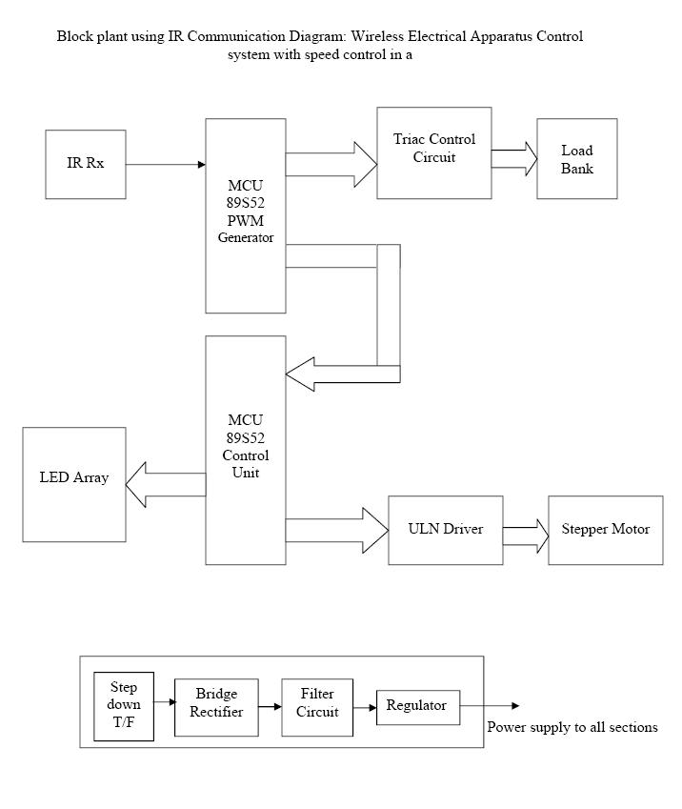

**Advantages:**

Easy to operate

Power saving

Best suitable for Bed-ridden patients

**Scopes for Advancements:**

Auto speed control based on temperature can be implemented using a temperature sensor.

**Applications:**

Industries, Hotels, Hospitals, Shops, Banks and offices